Tactivity 2: Identifying Correct and Incorrect Triangle Heights

Classification Tiles

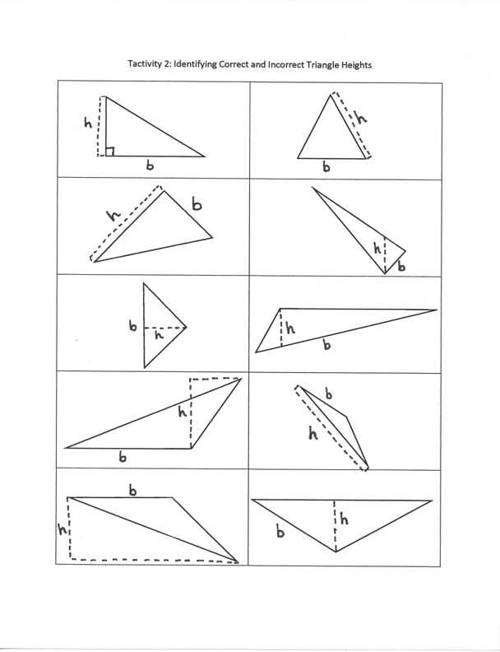

Classification Organizer

CORRECT HEIGHT | INCORRECT HEIGHT
TACTivity Directions

Materials:
- Classification Tiles
- Classification Organizer
- Ruler, string, highlighter (if necessary)

Purpose: To identify and categorize proper procedure and placement of heights of triangles.

Activity How-To:
- Print pages 1 and 2 of activity document (tiles and organizer).
- Cut out tiles (page 1) on dotted lines so that there are 10 independent manipulatives.
- Review the procedure for determining heights of various triangles.
- Using the given base, identify whether the drawn height of the triangle is correct or incorrect.
- Place tiles into corresponding categories on the Classification Organizer.
- When all groups are finished, compare answers and discuss any tiles that are in conflicting placements.

Debrief Questions:
- What strategies can we use to make sure we have identified the correct height of each triangle?
- How does changing a triangle’s base change its height?

